**About Us**

Cube is a collaborative project developed by Team CS2113T-F09-2 of the Module CS2113T, in Academic Year 2019/20 Semester 1, School of Computing (SoC), NUS (National University of Singapore).

**Project Team**

---------------------------------------------------------------------------------------------------------------------------

**Ian Chua**

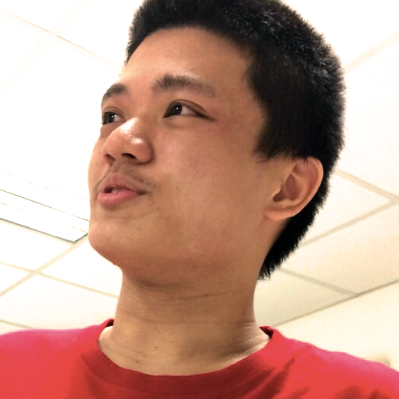

[[github](https://github.com/kuromono)]

Role: Developer

---------------------------------------------------------------------------------------------------------------------------

**Ye Guoquan**

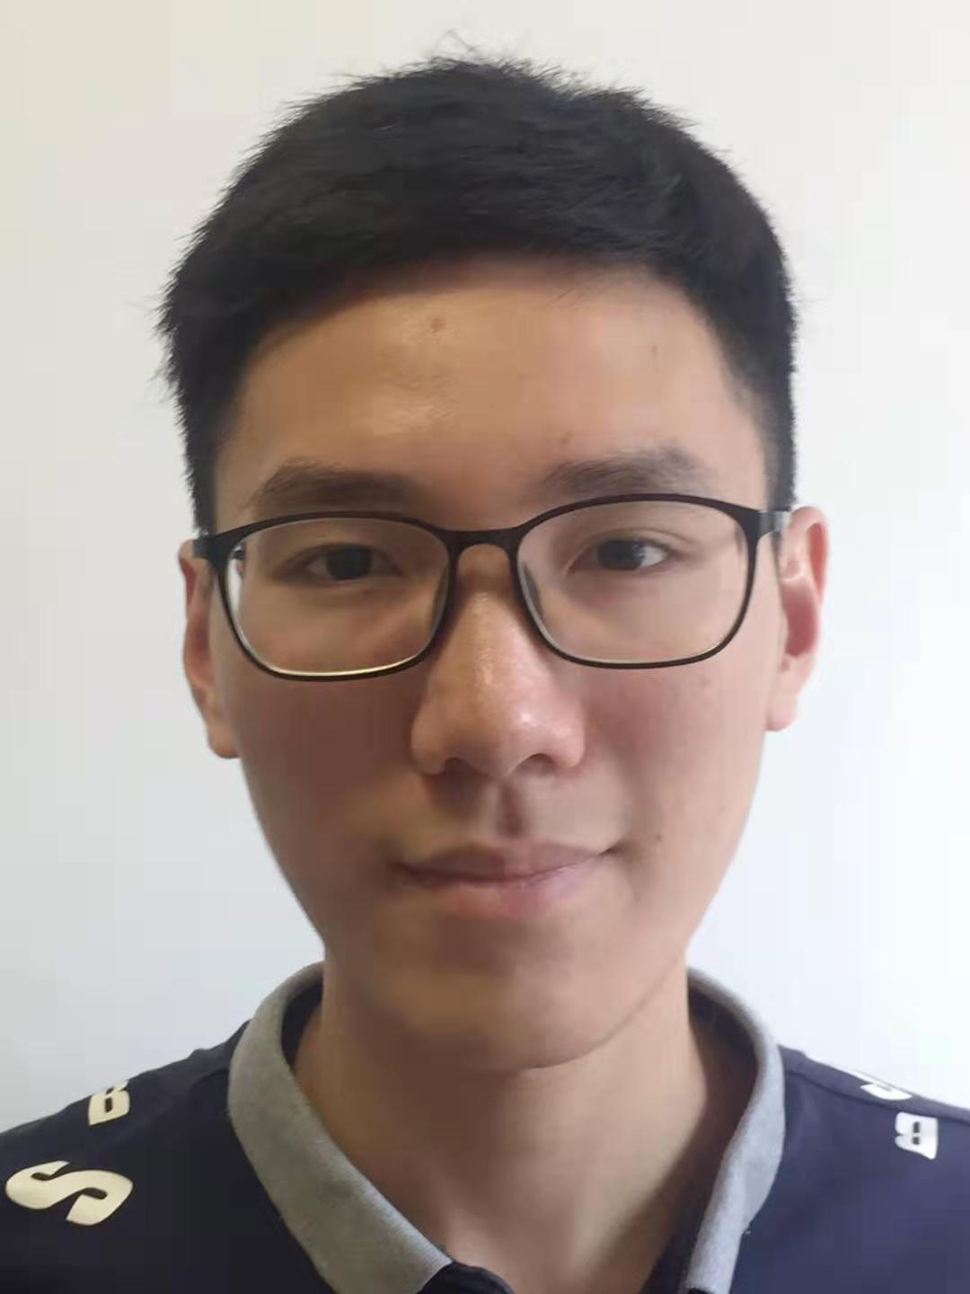

[[github](https://github.com/tygq13)]

Role: Developer

---------------------------------------------------------------------------------------------------------------------------

---------------------------------------------------------------------------------------------------------------------------

**Zhao Pengfei**

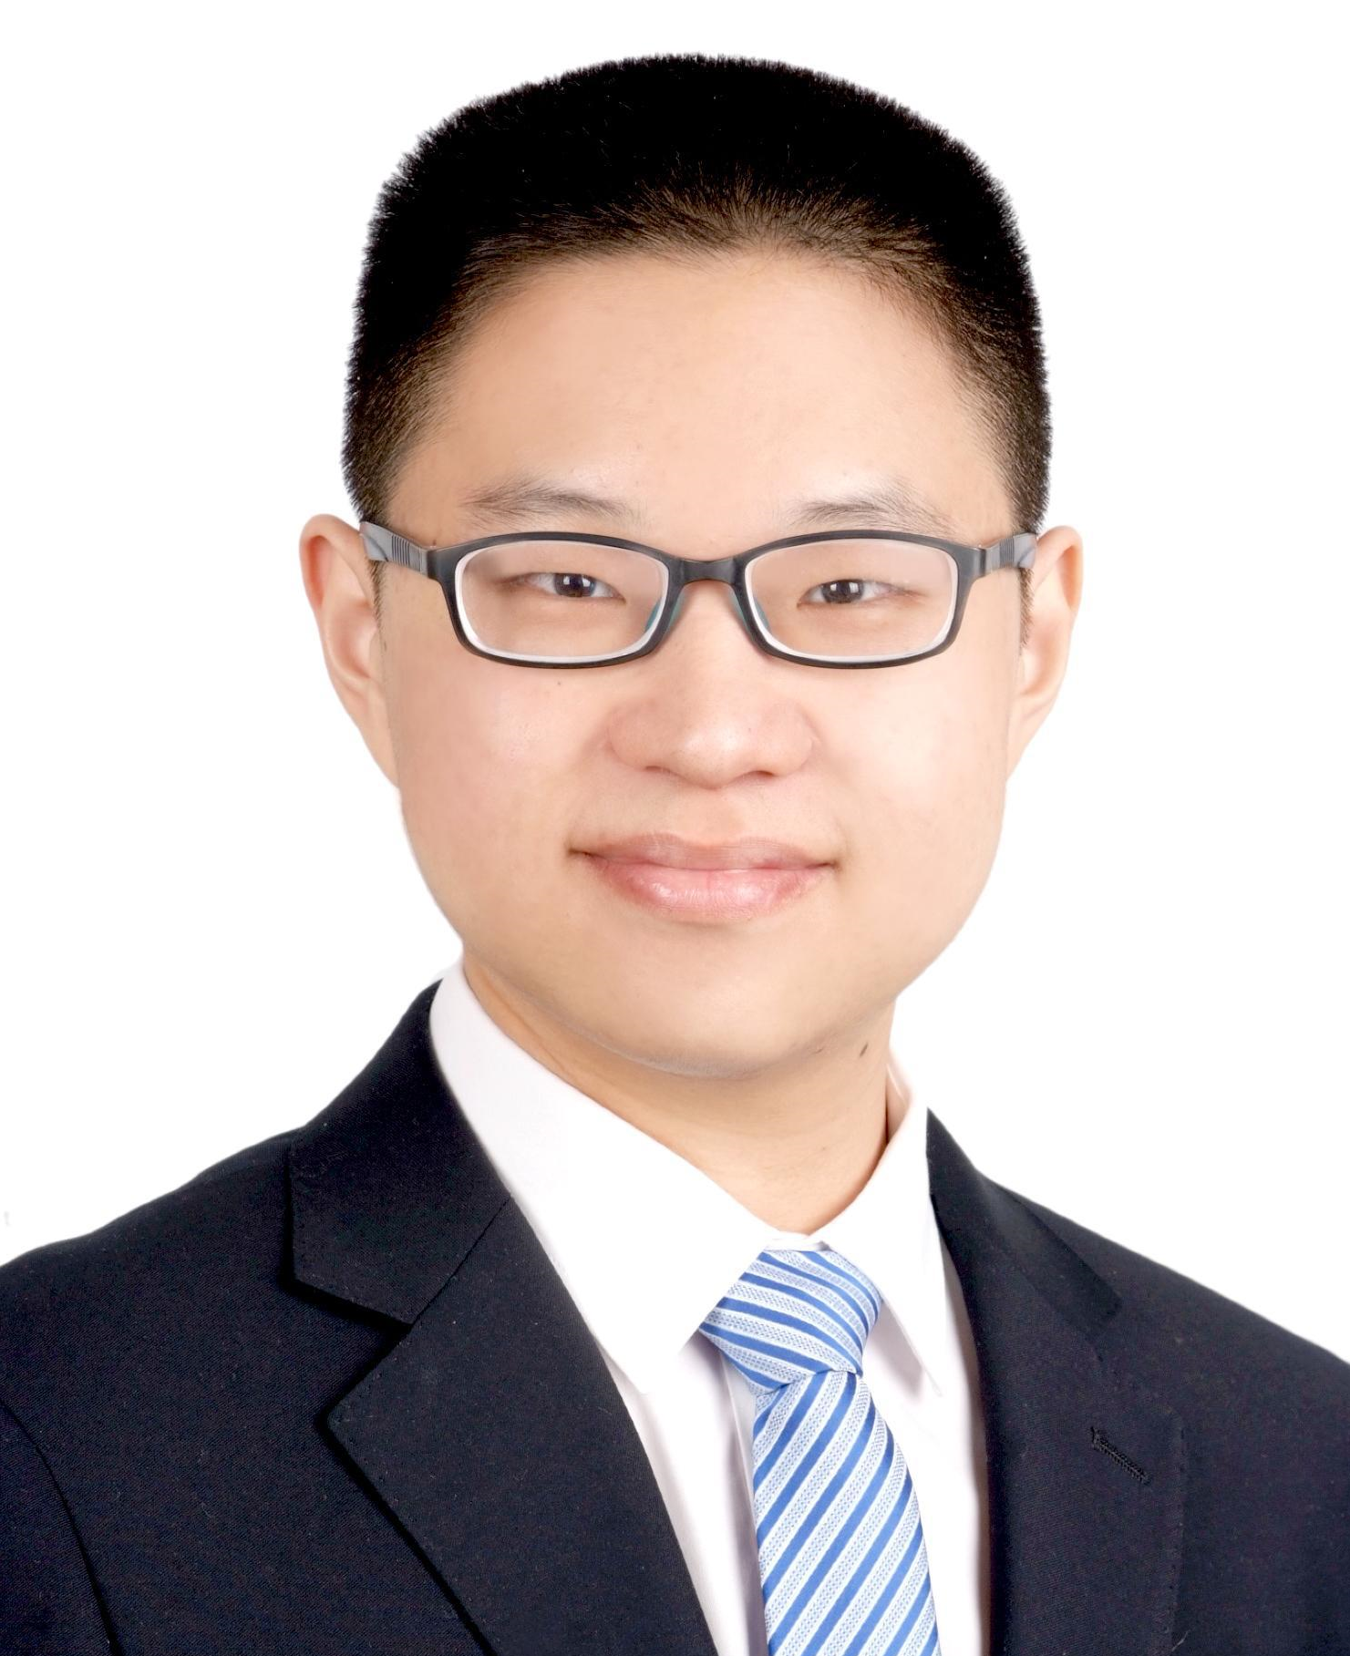

[[homepage](http://www.comp.nus.edu.sg/~pengfei)][[github](https://github.com/LL-Pengfei)][[portfolio](https://nus-csm.symplicity.com/profiles/zhao.pengfei)]

Role: Developer

---------------------------------------------------------------------------------------------------------------------------

**Zheng Kaining**

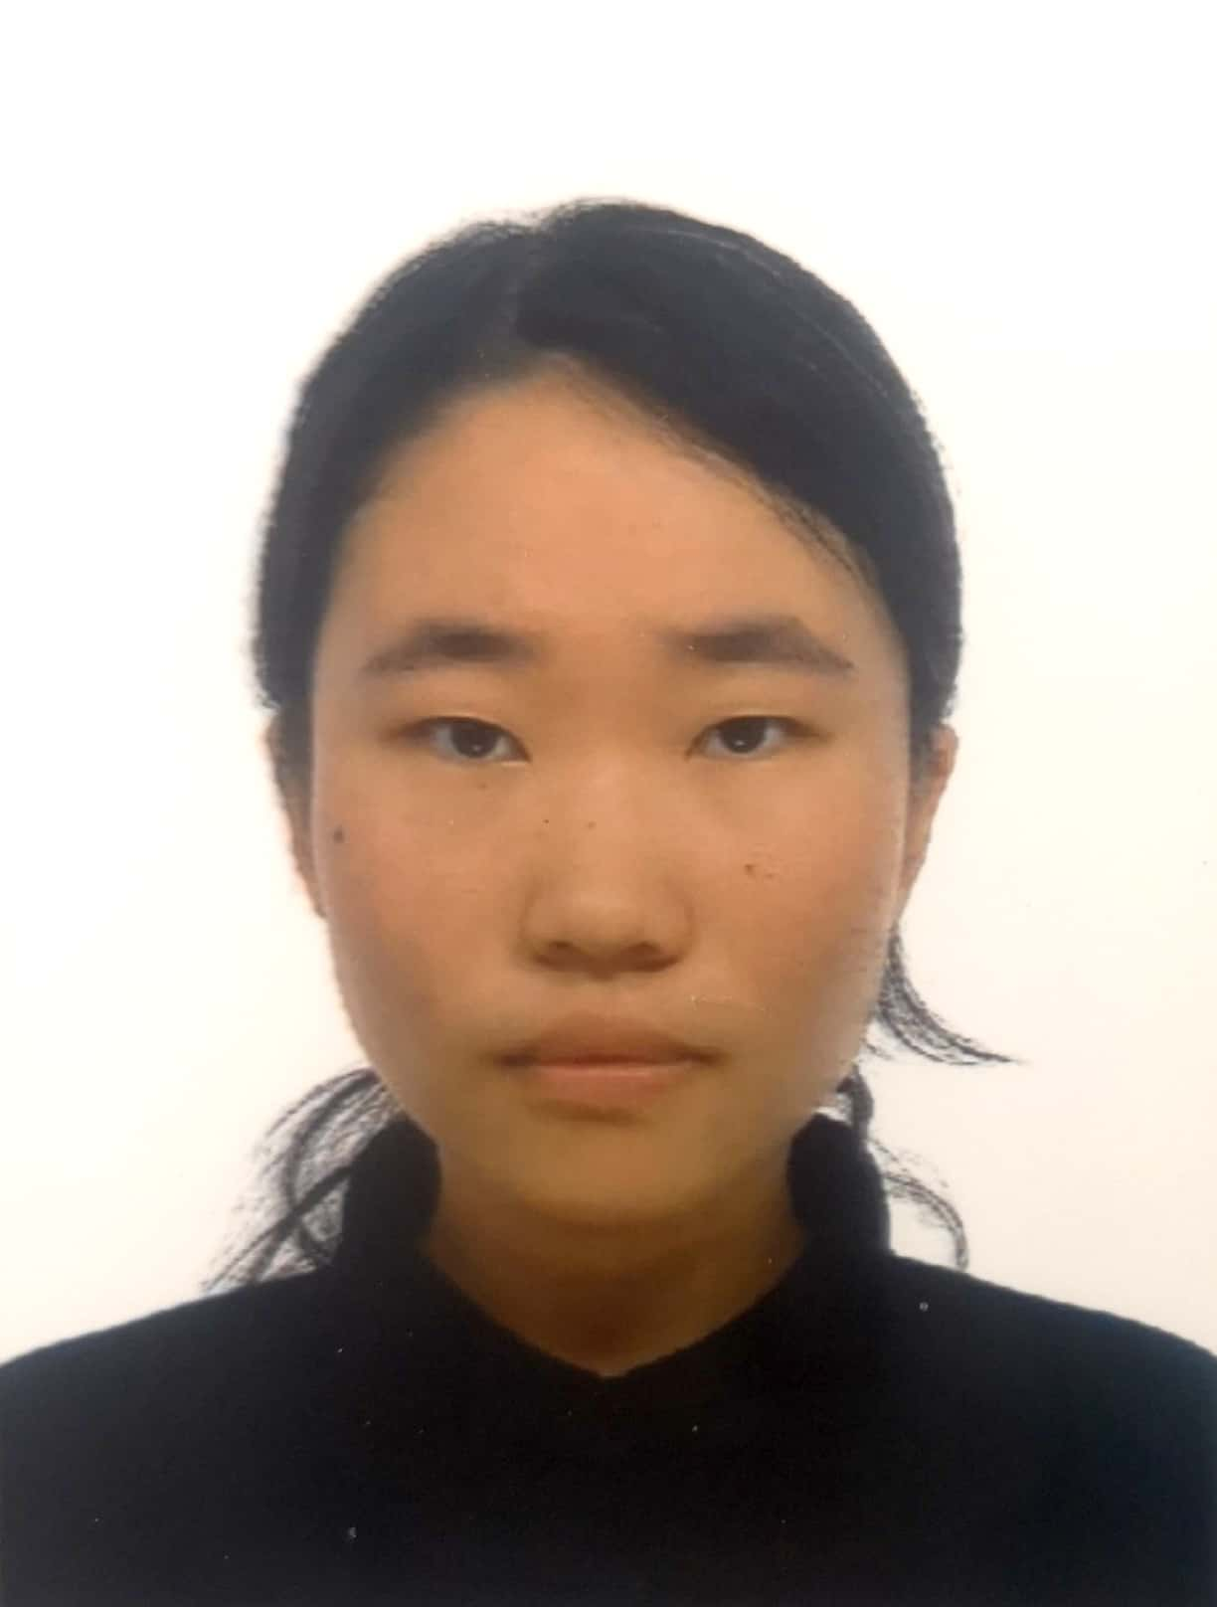

[[github](https://github.com/ZKathrynx)]

Role: Developer

---------------------------------------------------------------------------------------------------------------------------

---------------------------------------------------------------------------------------------------------------------------

**Parvathi Ranjith Menon**



[[github](https://github.com/parvathi14)]

Role: Developer

---------------------------------------------------------------------------------------------------------------------------